European Geography: Before and After WWI
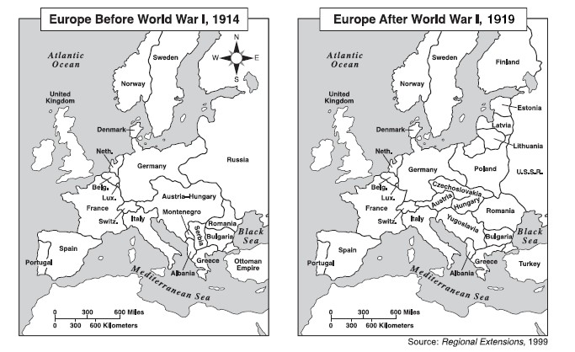
Directions: Examine the two maps below and then answer the questions based on your observations from the maps.

- What new countries were created as a result of the Treaty of Versailles?

- Which European countries lost territory as a result of the Treaty? Which country lost the most territory?

- Which European countries gained territory as a result of the Treaty of Versailles?

- Based on what you know about the treaty of Versailles and Woodrow Wilson’s 14 Points, explain why the Europeans decided to divide up Europe this way after WWI (explain in 2-3 complete sentences, continue on back if necessary).

